**QUESTION 4**

* **CODE :-**

f=open('myfile.txt','r')

r=f.read()

**#(A)**

a=r.split()

d={}

for i in a:

if i.lower() not in d:

d[i.lower()]=1

else:

d[i.lower()]+=1

print("(A)")

print(d)

print('(i) Total no. of words is:',len(a))

print('(ii) No. of different words are:',len(d))

x=0

for i in d:

if d[i]>x:

x=d[i]

for i in d:

if d[i]==x:

print(f'(iii) The most common words in the file is: "{i}"')

**#(B)(i)**

d2={}

for i in d:

if len(i) not in d2:

d2[len(i)]=[i]

else:

d2[len(i)].append(i)

print('\n\n(B)(i)',d2)

**#(B)(ii)**

def find_longest_word():

n=0

for i in d2:

if i>n:

n=i

for i in d2:

if i==n:

print(f'(ii) The longest words in the file are {d2[i]}')

**#(B)(iii)**

def filter_long_words(n):

l=[]

for i in d2:

if i>n:

l.extend(d2[i])

print(f'The list of words that are longer than {n} are:',l)

find_longest_word()

m=int(input('(iii) Enter the no. of letters to check for: '))

filter_long_words(m)

* **Text File (myfile.txt) :-**

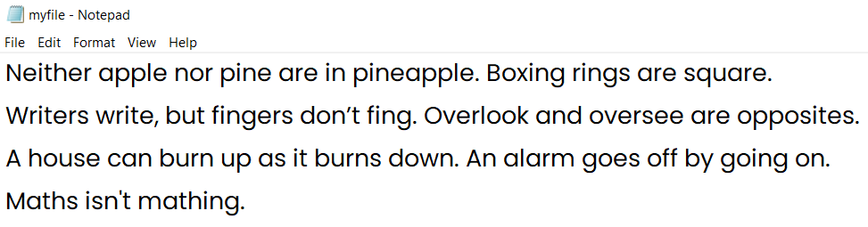

* **OUTPUT :-**

(A)

{'neither': 1, 'apple': 1, 'nor': 1, 'pine': 1, 'are': 3, 'in': 1, 'pineapple.': 1, 'boxing': 1, 'rings': 1, 'square.': 1, 'writers': 1, 'write,': 1, 'but': 1, 'fingers': 1, 'don’t': 1, 'fing.': 1, 'overlook': 1, 'and': 1, 'oversee': 1, 'opposites.': 1, 'a': 1, 'house': 1, 'can': 1, 'burn': 1, 'up': 1, 'as': 1, 'it': 1, 'burns': 1, 'down.': 1, 'an': 1, 'alarm': 1, 'goes': 1, 'off': 1, 'by': 1, 'going': 1, 'on.': 1, 'maths': 1, "isn't": 1, 'mathing.': 1}

(i) Total no. of words is: 41

(ii) No. of different words are: 39

(iii) The most common word in the file is: "are"

(B)(i) {7: ['neither', 'square.', 'writers', 'fingers', 'oversee'], 5: ['apple', 'rings', 'don’t', 'fing.', 'house', 'burns', 'down.', 'alarm', 'going', 'maths', "isn't"], 3: ['nor', 'are', 'but', 'and', 'can', 'off', 'on.'], 4: ['pine', 'burn', 'goes'], 2: ['in', 'up', 'as', 'it', 'an', 'by'], 10: ['pineapple.', 'opposites.'], 6: ['boxing', 'write,'], 8: ['overlook', 'mathing.'], 1: ['a']}

(ii) The longest words in the file are ['pineapple.', 'opposites.']

(iii) Enter the no. of letters to check for: 4

The list of words that are longer than 4 are: ['neither', 'square.', 'writers', 'fingers', 'oversee', 'apple', 'rings', 'don’t', 'fing.', 'house', 'burns', 'down.', 'alarm', 'going', 'maths', "isn't", 'pineapple.', 'opposites.', 'boxing', 'write,', 'overlook', 'mathing.']